Setting up nOps
- Make sure your AWS Cloudtrail service is enabled. Make sure the logging has started. Default settings are fine.
- Make sure your billing setting in AWS console looks like the following screenshot. Please check your billing bucket in a day or two to make sure the billing files are present.

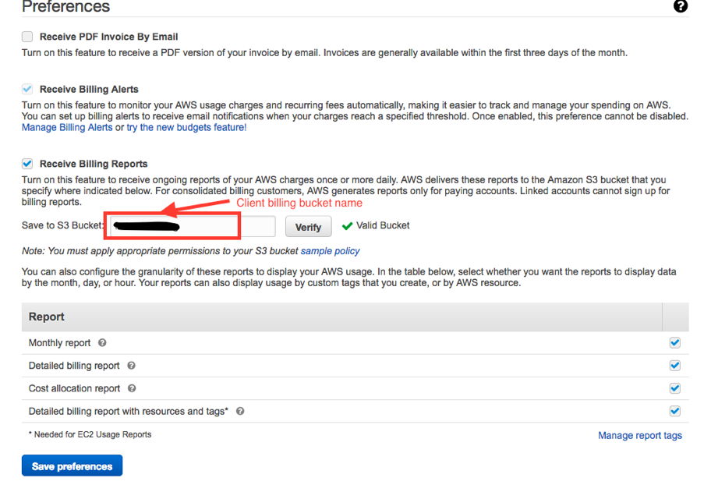
Creating Policy
- From AWS console login, go to ‘Identity and Access Management’ screen.
- From the left navigation panel choose ‘Policies’
- Click on ‘Create Policy’.
- Choose ‘Json Tab’
- Replace the existing Json script with the script given below and the click on ‘Review Policy’
- Provide some name and some description to the policy.
- Click on ‘Create Policy’.

Bucket Policy Last Updated: 19 April, 2018
{
"Version": "2012-10-17",
"Statement": [
{
"Effect": "Allow",
"Action": [
"s3:*"
],
"Resource": [
"arn:aws:s3:::bucket_name",
"arn:aws:s3:::bucket_name/*"
]
},
{
"Action": [
"autoscaling:Describe*",
"ce:*",
"cloudformation:Describe*",
"cloudformation:GetTemplate",
"cloudformation:List*",
"cloudfront:Get*",
"cloudfront:List*",
"cloudtrail:DescribeTrails",
"cloudtrail:GetTrailStatus",
"cloudtrail:LookupEvents",
"cloudwatch:Describe*",
"cloudwatch:Get*",
"cloudwatch:List*",
"config:DescribeConfigurationRecorderStatus",
"config:DescribeConfigurationRecorders",
"config:DescribeDeliveryChannelStatus",
"config:DescribeDeliveryChannels",
"config:Get*",
"config:GetResourceConfigHistory",
"config:GetResources",
"config:GetTagKeys",
"dynamodb:Describe*",
"dynamodb:DescribeStream",
"dynamodb:GetRecords",
"dynamodb:GetShardIterator",
"dynamodb:List*",
"ec2:Describe*",
"elasticache:Describe*",
"elasticloadbalancing:Describe*",
"iam:Get*",
"iam:List*",
"opsworks:Describe*",
"opsworks:Get*",
"rds:Describe*",
"rds:ListTagsForResource",
"route53:Get*",
"route53:List*",
"route53domains:Get*",
"route53domains:List*",
"s3:List*",
"s3:Get*",
"support:*",
"trustedadvisor:Describe*",
"lambda:Get*",
"lambda:List*"
],
"Effect": "Allow",
"Resource": "*"
}
]
}

Creating Roles
- From the left navigation panel choose ‘Roles’
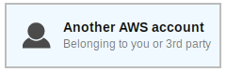
- Click on ‘Create New Role’
- Select type of trusted identity: Choose

- Specify accounts that can use this role: AWS will ask for Account ID and External ID. For Account ID enter the nOps account ID (202279780353) and for External ID, enter any unique string. The External ID adds an extra level of security for you. When finished, select Next Step. Please do not check ‘Require MFA’ .
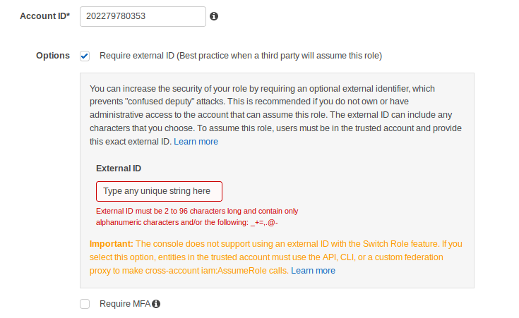

- On Next Step, we will attach policy created in earlier task and click on ‘Next:Review’
- Provide some name and description to the role and click on ‘Create Role’
- Return to nOps to complete setup.

In nOps.io:
- Go to Settings [ Under user name drop down menu]
- In Settings page, click Project Settings Icon.
- Add Project.
- Add billing bucket name to the project that you just created. Make sure the billing bucket name is the same as the S3 bucket you created for billing.
- Make sure you save the setting.
It’ll take about a day for billing data to populate. It’ll take a couple of hours for CloudTrail data to populate. If you have any questions, please contact us at support@nops.io, or by phone at +1 866-673-9330.

